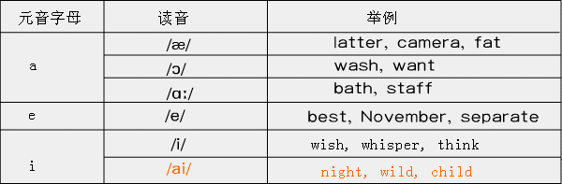

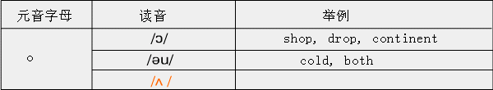

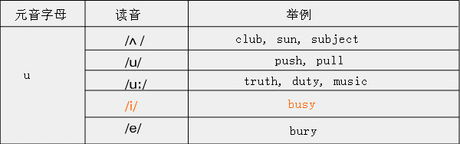

元音字母在非重读音节中的读音比较复杂，见下表：
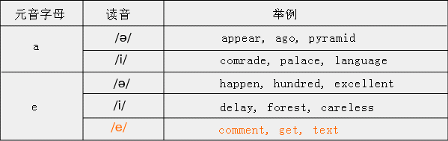

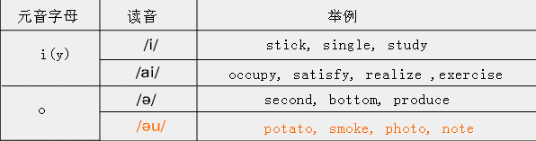
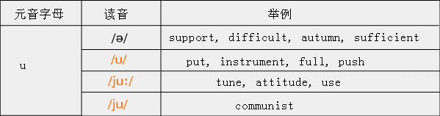

重读r音节读音比较固定，如：
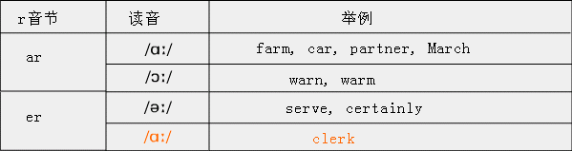

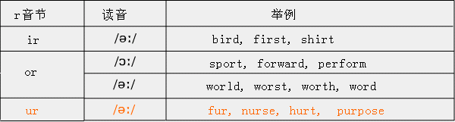

二、辅音字母的读音规则
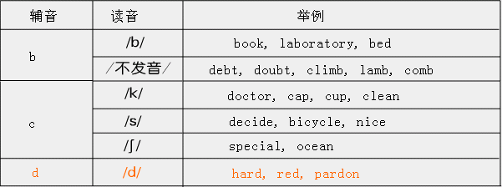

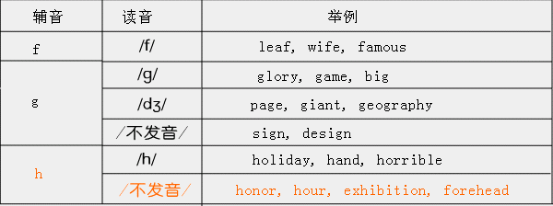

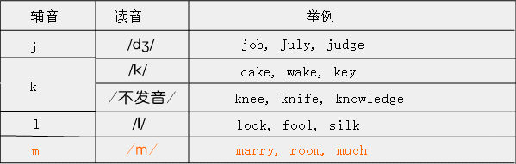

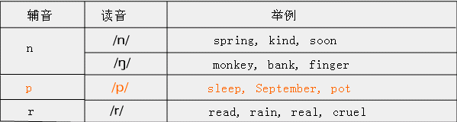

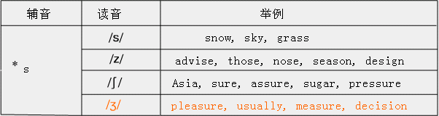

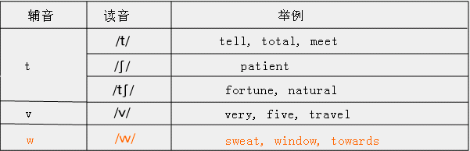

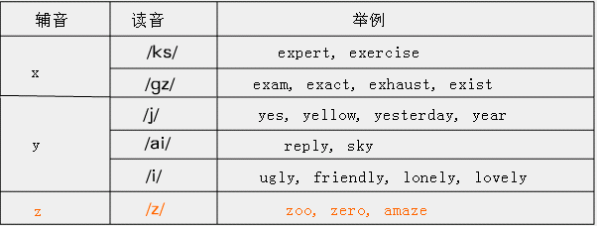

三、常见字母组合的读音规则
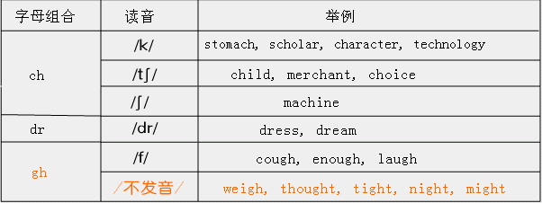

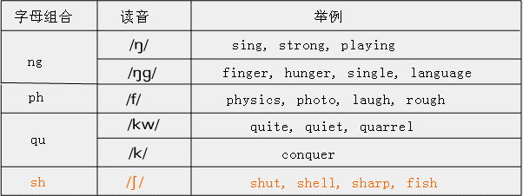
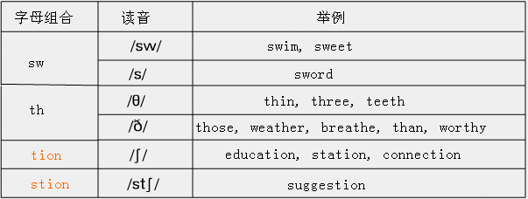

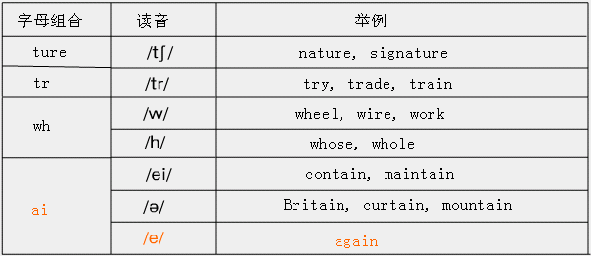

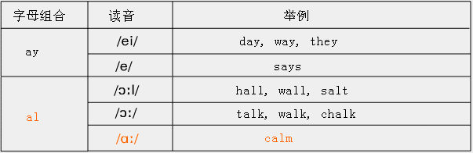

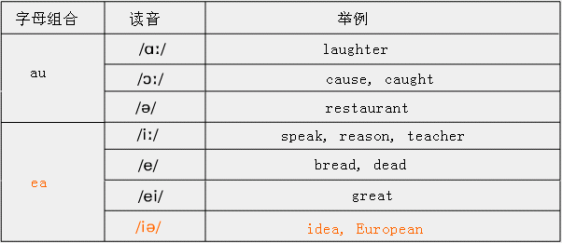

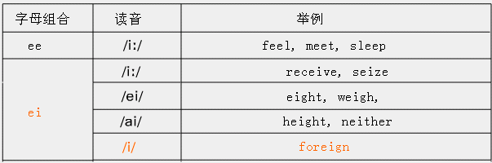

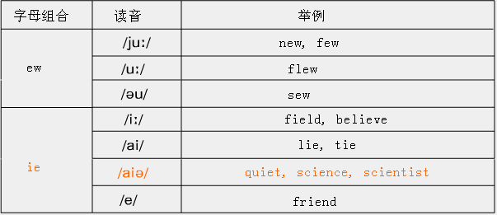

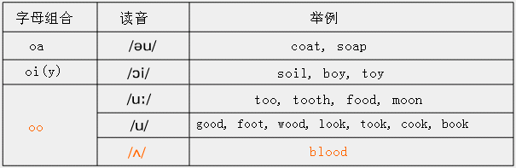

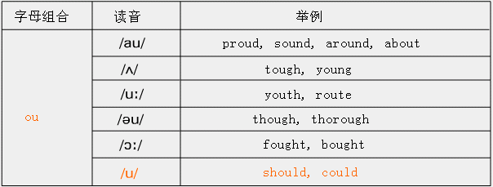

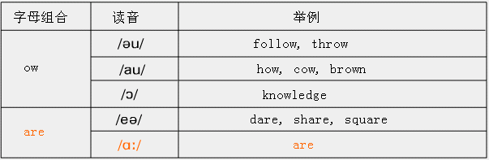

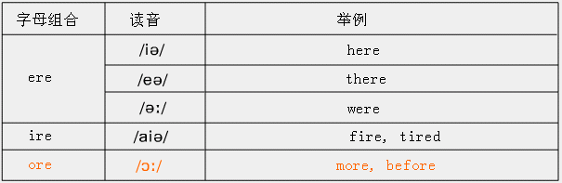

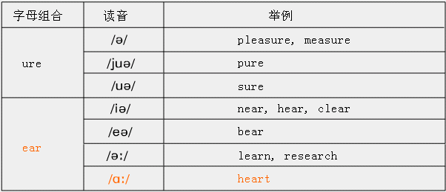

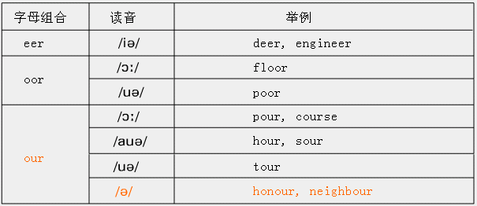

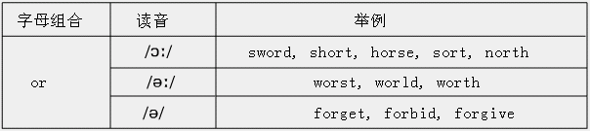

*s构成名词复数、动词一般现在时第三个人称单数时，在清辅音后读/s/，如helps, asks;
在元音、浊辅音后读/z/， 如knives, shows, plans；
在/s/,/z/,//,/t/,/d/后读/iz/，如faces, rises, brushes, watches, urges。

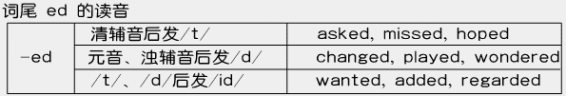

四、考点测验
1. A. admire B. against C. anxious D. announce
2. A. watch B. catch C. match D. snatch
3. A. energy B. engineer C. encourage D. entrance
4. A. practice B. possible C. physical D. Pacific
5. A. official B. observe C. obey D. obviously

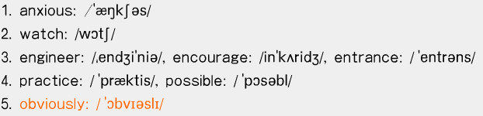

6. A. subject B. succeed C. supply D. suppose
7. A. cloudy B. captain C. certain D. cotton
8. A. league B. tongue C. guess D. guest
9. A. honor B. however C. handsome D. harmful
10. A. knock B. knowledge C. kilometer D. knee

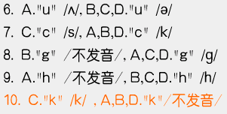

11. A. strong B. English C. finger D. longer
12. A. season B. serious C. promise D. advise
13. A. umbrellas B. victories C. workshops D. vegetables
14. A. pollutes B. pronounces C. prepares D. persuades
15. A. example B. explain C. expensive D. excuse

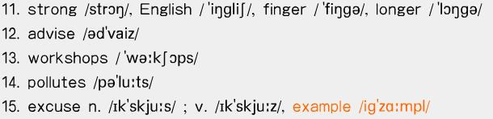

16. A. apology B. especially C. yard D. February
17. A. school B. machine C. technical D. character
18. A. where B. while C. whole D. white
19. A. both B. thin C. this D. think
20. A. three B. those C. thank D. theatre

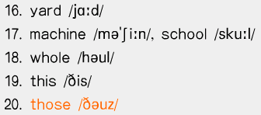

21. A. liberation B. suggestion C. attention D. education
22. A. warm B. armful C. party D. harvest
23. A. call B. calm C. talk D. walk
24. A. steal B. real C. reality D. meal
25. A. wheat B. cheat C. treat D. sweat

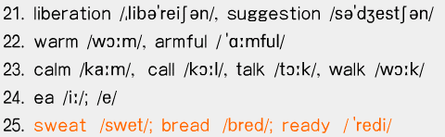

26. A. percent B. permit C. person D. persuade
27. A. friend B. field C. handkerchief D. achieve
28. A. eight B. weight C. height D. neighbour
29. A. boot B. choose C. soon D. stood
30. A. corn B. sport C. horse D. worse

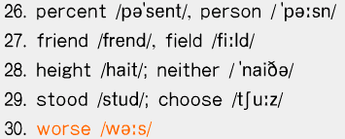

31. A. country B. touch C. mouth D. double
32. A. about B. could C. account D. shout
33. A. known B. shown C. thrown D. brown
34. A. own B. follow C. know D. knowledge
35. A. fear B. dear C. heard D. near

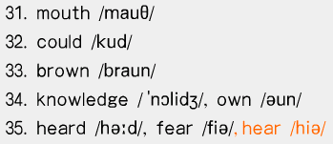

36. A. pleasure B. pressure C. measure D. treasure
37. A. reported B. watched C. depended D. wounded
38. A. weighed B. washed C. warned D. wondered
39. A. swim B. sweet C. sweat D. sword
40. A. spare B. prepare C. stare D. are

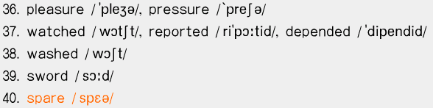

五、语音考试样题―― 样题一
Directions:
In each of the following groups of words, there are four underlined letters or letter combinations marked A, B, C and D. Compare the underlined parts and identify the one that is different from the others in pronunciation. Mark your answer by blackening the corresponding letter on ANSWER SHEET.

1. A. back B. safely C. table D. strange
2. A. rare B. square C. care D. are
3. A. taught B. caught C. laughter D. daughter
4. A. white B. whisper C. whose D. wheel
5. A. kick B. resist C. silver D. April

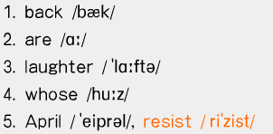

6. A. anxious B. answer C. angry D. angle
7. A. cover B. crop C. create D. cycle
8. A. dumb B. establish C. debt D. doubtful
9. A. easy B. reply C. simply D. highly
10. A. express B. extra C. expert D. export

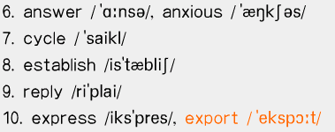

五、语音考试样题―― 样题二
1. A. neighbour B. height C. weight D. eighty
2. A. bathroom B. eleventh C. breathe D. maths
3. A. lecture B. recognize C. level D. recent
4. A. put B. push C. public D. pull
5. A. comfortable B. possible C. horrible D. constant

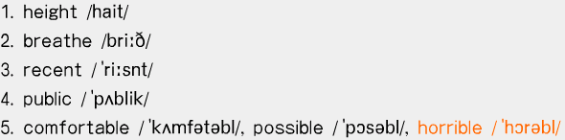

6. A. climb B. mind C. sign D. print
7. A. measure B. health C. theatre D. ready
8. A. hall B. shall C. fall D. small
9. A. pleasure B. visitor C. raise D. physics
10. A. flow B. plow C. slow D. yellow

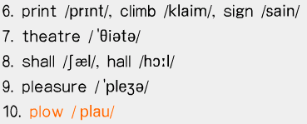

五、语音考试样题―― 样题三
1.A. deal B. deaf C. weak D. beat
2. A. liberate B. liquid C. limit D. lively
3. A. social B. officer C. percent D. Pacific
4. A. childhood B. chicken C. character D. chairman
5. A. worst B. horse C. northern D. sort

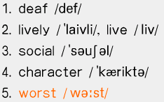

6. A. hospital B. honour C. hotel D. however
7. A. manage B. matter C. madam D. many
8. A. gather B. government C. geography D. garden
9. A. said B. laid C. gain D. pain
10. A. light B. fright C. daughter D. cough

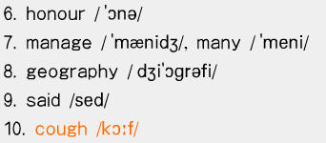

★大纲上给了3000个常用单词，平时读的时候注意发音

